Installation of git in MAC

For latest git do installation as below

- Navigate to http://git-scm.com/download/mac and download.
- Once download is done , open the DMG and double click the .pkg file
- Once the installation is successful,launch terminal and type git –version
- git version should display the downloaded file version

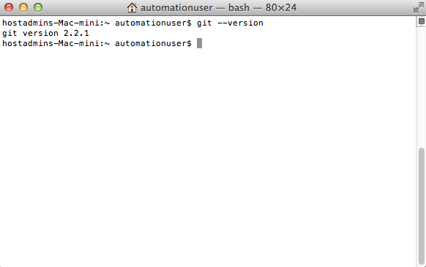

If the latest verison in not displayed in step 4 do following work around

$ echo "export PATH=/usr/local/git/bin:/usr/local/bin:/usr/local/sbin:$PATH" >> ~/.bash_profile

# Tell the Terminal to look at your bash_profile to get the updated order of folders (your "$PATH")
$ source ~/.bash_profile

# Now let's check your Git version again
$ git --version

Through Terminal(git is not the latest version)

- Open Terminal and type git.
- If git is not available it prompts to install git.
- Click on 'OK'.
- Download and installation happens ,status is shown on progress bar
- Once the installation completes.
- Open terminal
- Type git –version
- git version gets displayed

